The application window for the **3rd Quarter Individual Equity Review** request process is opening **August 1st** and will remain open until **August 31st.**

When completing your application, please keep in mind that the Joint Programs Committee is looking for the following details: **identification** of a problem; the **recommendation** of a solution; and the **implementation** of a solution.

The electronic Equity Review application is available on the Leave Request site and submissions should be submitted directly to [tullabor@spiritaero.com.](mailto:tullabor@spiritaero.com.)

Should you have trouble accessing the site, Equity Review applications have also been provided to all Spirit managers and UAW Leadership.

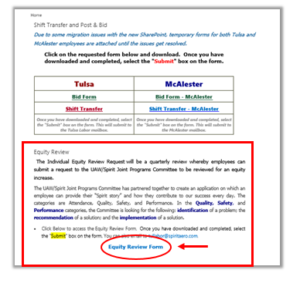

Link: <https://spiritaerosystems.sharepoint.com/sites/Time_Keeping/default.aspx>

The Joint Programs Committee